Karol Rodak

MULTISCALE MODELLING – FIRST REPORT

1. USED TECHNOLOGY

.NET Framework – is a software framework developed by Microsoft. It provides programming environment to develop software. It is not related with one programming language, programs can be developed for example in C++/CLI, C#, F#, J#, Delphi .Net, Visual Basic .NET and others. Main parts of .NET Framework are Framework Class Library (FCL) and Common Language Runtime (CLR). FCL provides user interface, data access, database connectivity, cryptography, web application development, numeric algorithms, and network communications. CLR allows programs developed in .NET to provide management of memory usage, exception handling and security. Microsoft produces an integrated development environment for .NET software called Visual Studio.

Windows Presentation Forms (WPF) – GUI framework for rendering user interfaces, creating desktop client Windows-based aplications. GUI allows you to create an application with a wide range of GUI elements, like labels, textboxes and other elements and handle all of the user interaction scenarios like text and mouse input. WPF is the successor of WinForms GUI. WPF uses the Extensible Application Markup Language (XAML) to provide a declarative model for application programming.

2. DESCRIPTION OF USER INTERFACE

Main function of the program is to simulate grain growth in the microstructure and different processes connected with that. The figure no.1 below presents graphical user interface of created program.

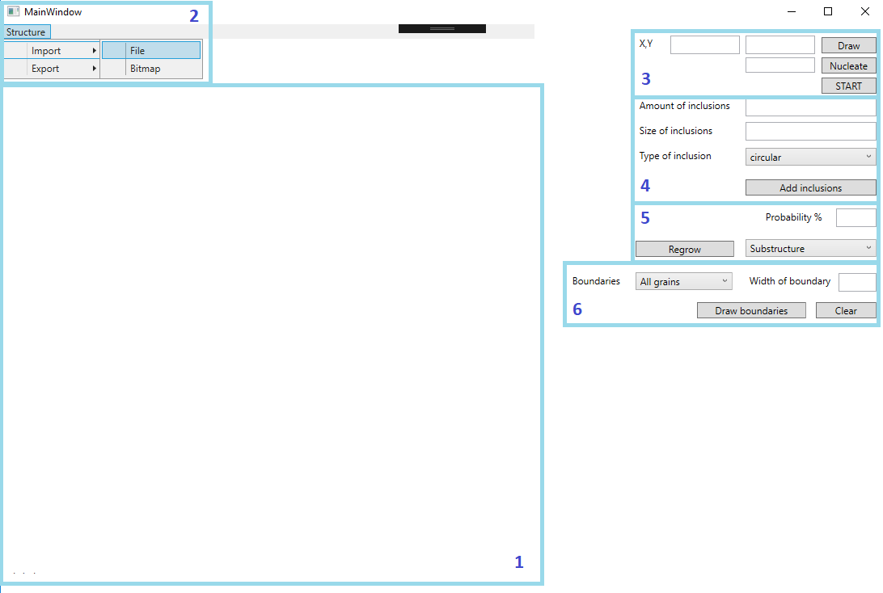

*Figure 1*

Elements of GUI are grouped and colored in sections to describe them in proper way.

First part of interface is image where microstructure will be rendered by drawing every grain of microstructure. Grains are in different colors, randomly selected, to improve recognition every part of microstructure.

Second section is a simple menu where user can import or export microstructure to file. There are 2 types of files, which are supported in implementation. First type is a bitmap file representing image of microstructure where every pixel symbolizes one grain of the microstructure. Second type of file is text file, where are saved all specifications of the grain like id, position of the grain, colour, state or type of the grain etc. User can save to file generated microstructure or import some created earlier to work on it.

Next section of the program is responsible for creating a microstructure with proper dimensions, determined by number of grains horizontally and vertically. By “Nucleate” button click user nucleates number of grains which is written in textbox near this button. “Start/Stop” button start or stop the process of grain growth.

In the next part of the program user can add inclusions to microstructures. By filling the textboxes he decides about amount and size of inclusions. It is possible to select from 2 types of inclusions: circular and diagonal. In the first case size of inclusion means the radius, in the second one the half of diagonal of inclusion. Inclusion can be created at the beginning of simulation or at the end of it.

In the fifth section user decides about chance to change some grain in algorithm by select some value from 1 to 100. There is also select between types of regrowth: dual-phase or substructure. After choose some option user should click in some grains which have to be considered in regrowth.

The last section of interface is responsible for creating boundaries of the grains. User select between ale grains or only selected grain. Selection is made by clicking in grains. “Clear” button clear all grains into white color. In the structure left only boundaries of the grains. Then it is possible to nucleate microstructure again and run a simulation.

3. PROGRAM FUNCTIONS

First function of the program is simulating simple grain growth with non-boundary condition ( Figure 2).

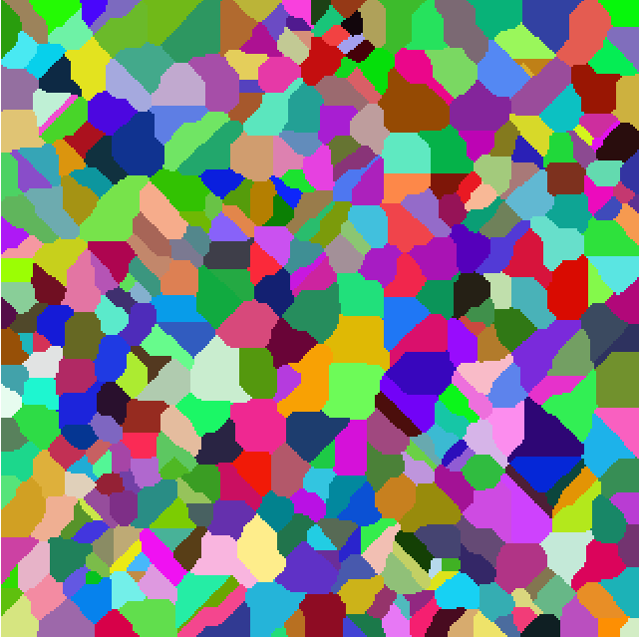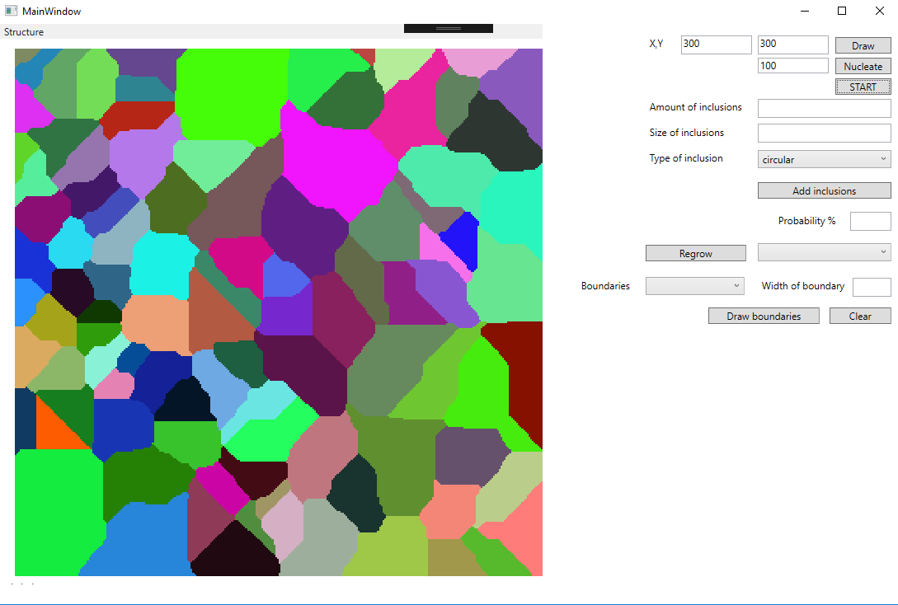

*Figure 2*

Generated model of microstructures is determined by parameters selected at the beginning. Setting a number of grains horizontally and vertically or number of grains to nucleate influences to different microstructure at the end of simulation. That is involved with create different material, different specification in the real process.

Other function is to export generated microstructure or import some from file (Figure 3).

User can choose these options from simple menu.

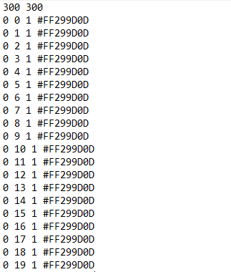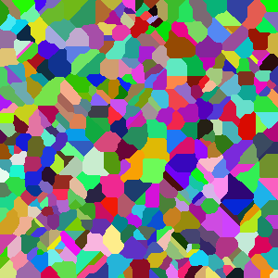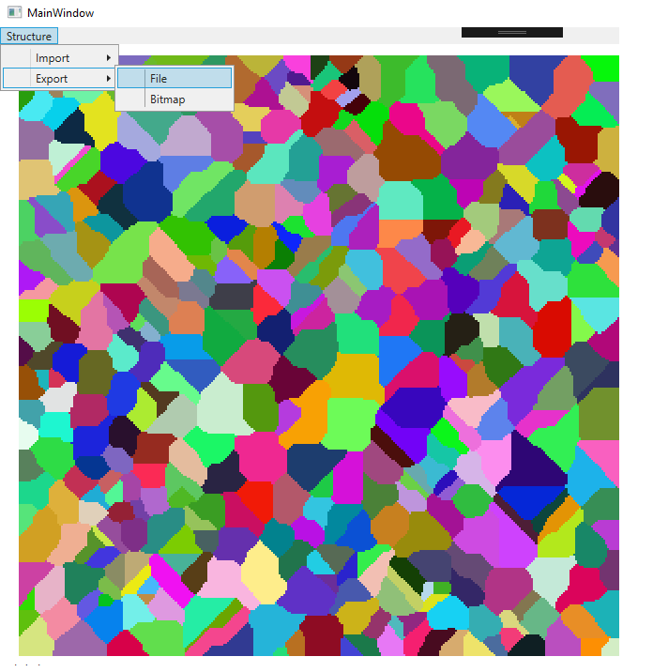

*Figure 3*

Importing file as a bitmap specification of every grain is recognized by color of this grain. Every empty grain, before growth is white and every inclusion has a black color. Other grains with the same color are grouped to make one part of microstructure. Exporting microstructure to text file at the beginning are saved dimensions of the microstructure, then position of grain, state and color. Recognition of the grains is similar to recognition from the bitmap file.

Inclusions can be added at the beginning of the simulation or at the end (Figure 4). When inclusions are added at the end can be only generated in boundaries of grains. The algorithm checks if all grains are filled and state is changed to recognize where inclusion should be placed. During the simulation inclusions are barriers for growing grains and can not to be considered as a neighbor of grain.

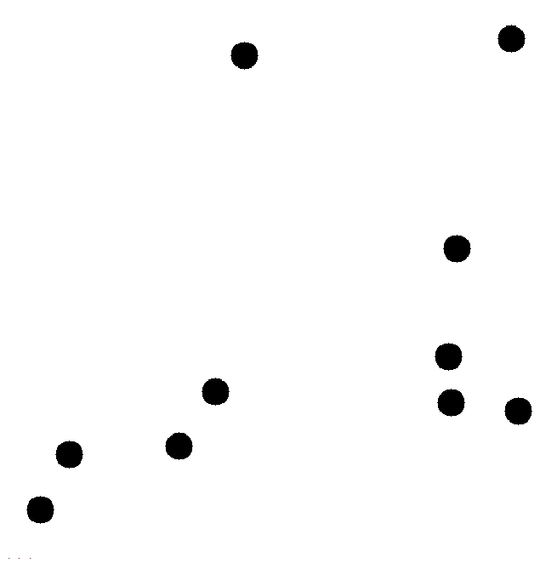

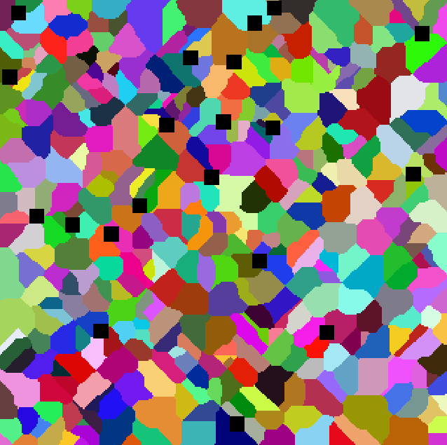

*Figure 4*

Change of probability to change grain in 4 rule of algorithm influence the regularity of created grains. If the probability is lower grains are more non regular. When probability is high shape of grain is simplest (Figure 5 and 6).

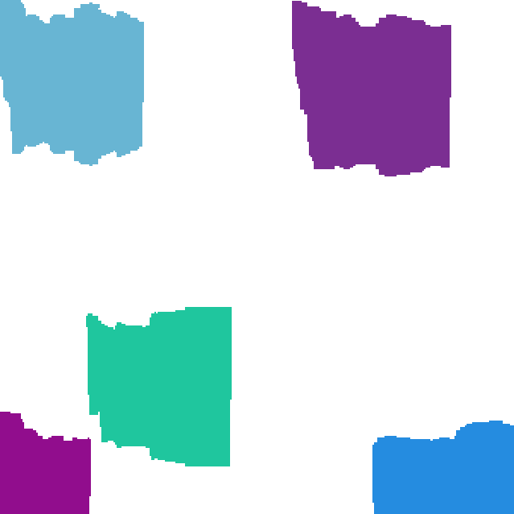

*Figure* *5*

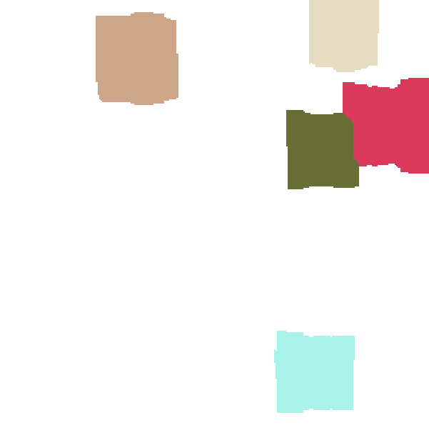

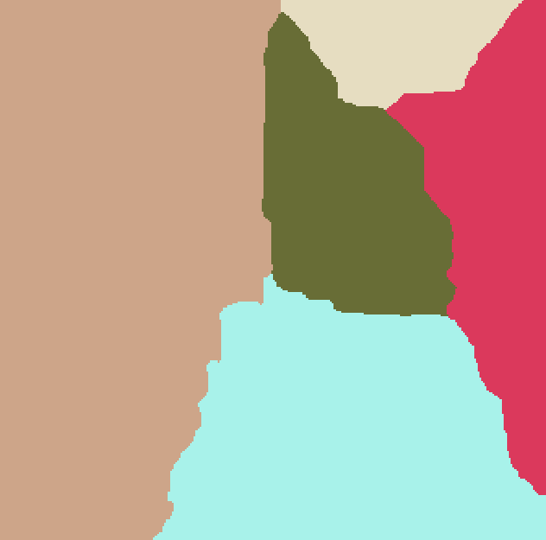

*Figure 6*

Next function of program is making substructures or dual phase from generated microstructure. Grains are selected by clicking at the image. Then grains get new id, new color if dual phase option is selected. In case of substructure selected grains have same colors and ids. Then new grains are nucleated. The next step is growth of new grains but selected grains as substructure or dual-phase is considered as inclusions so it not take part into counting neighbors and these not grow more (Figure 7).

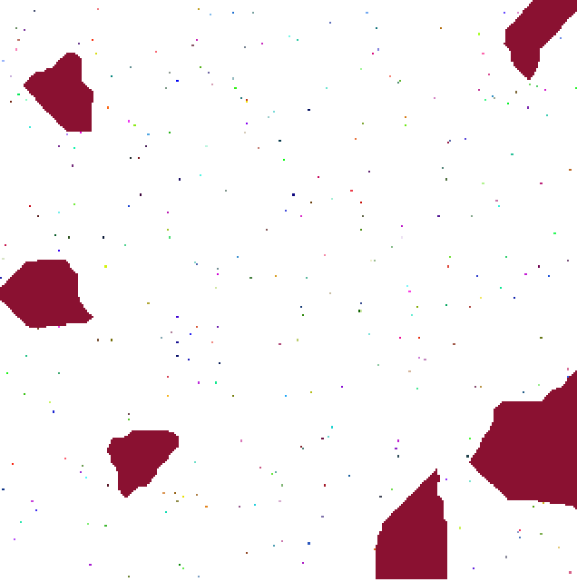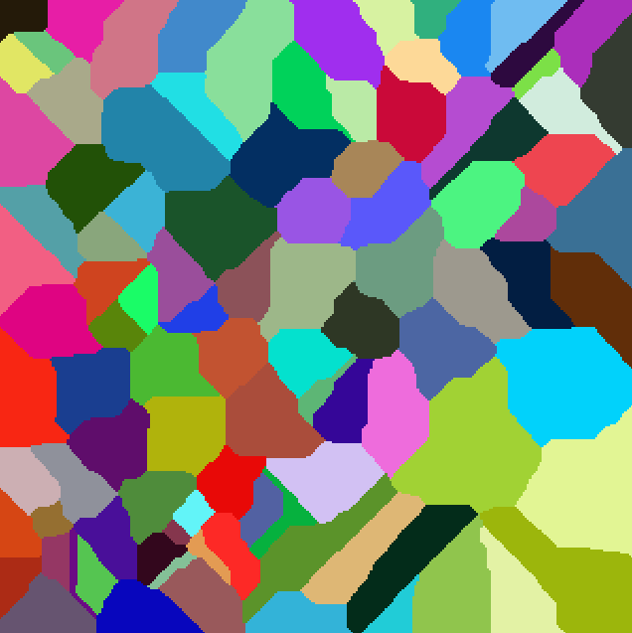

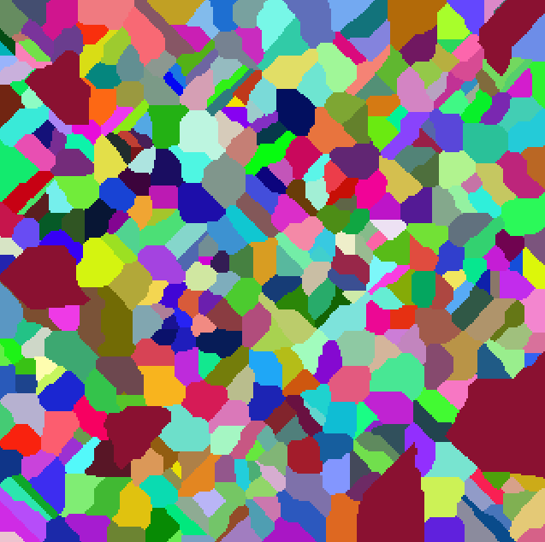

*Figure 7*

The last part of application is drawing boundaries between grains. There are also 2 options to select: all grains or selected grains. When user wants to draw boundaries at only few grains he should select grains by clicking them. Then the microstructure is cleared, so the color of grains is set to white and state to 0. On the microstructure left only boundaries which are in role of inclusions. Next step is nucleating new grains, but selecting place of new grains is connected with boundary option chosen by user. In case of all grains option new grains are nucleating everywhere in the middle of boundary grains but during the growth these can not to cross the boundary lines. In selected grains option grains are nucleated everywhere except middle of selected grains. Then, during the growth these cannot get into the middle of selected grain. The width of boundaries is number of pixels which boundary is made of (Figure 8)

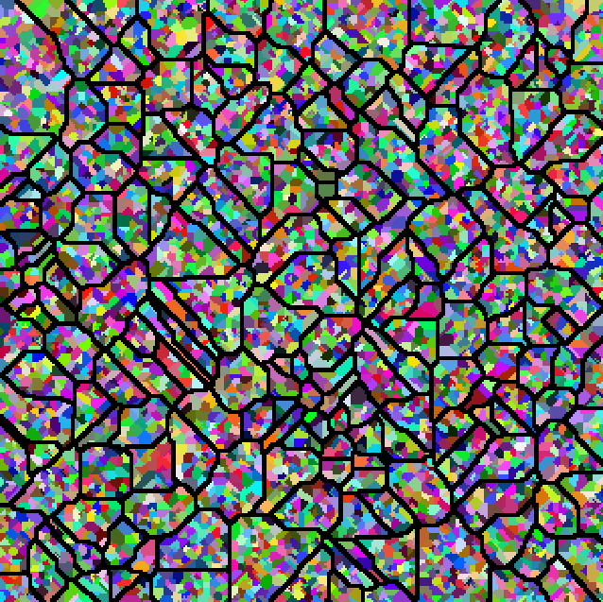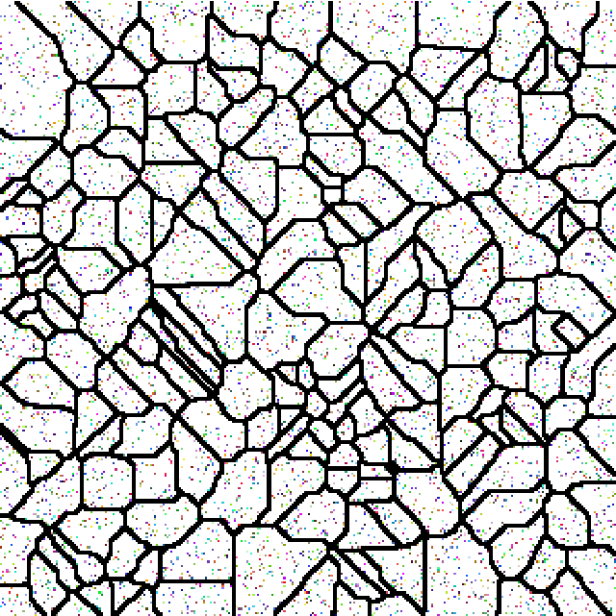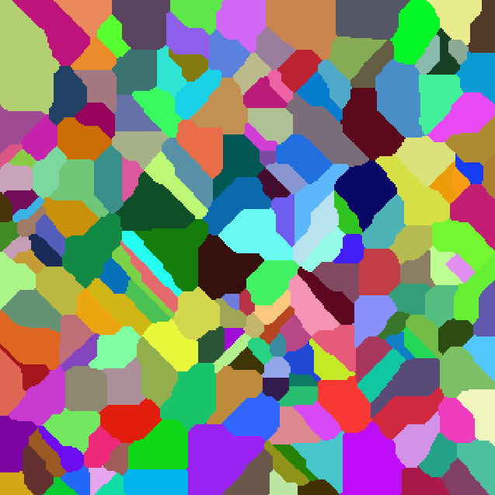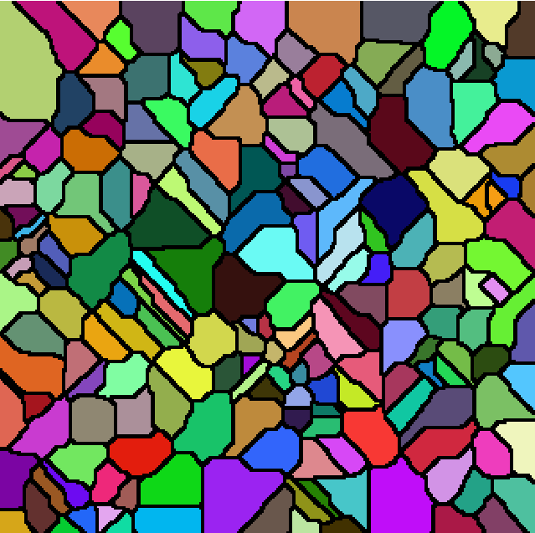

*Figure 8*

4. COMPARISON OF GENERATED MICROSTRUCTURES WITH REAL MICROSTRUCTURES

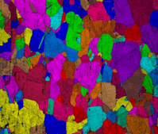

Figure 9a Figure 9b

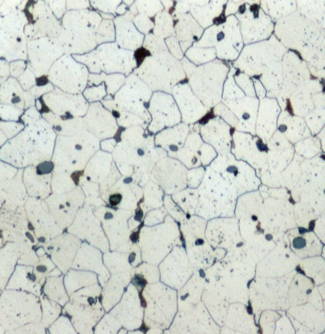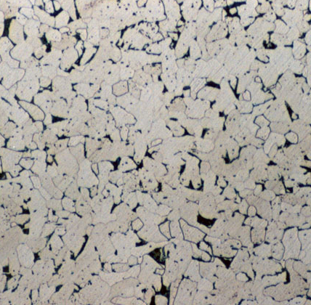

Figure 9c Figure 9d

Taking images of real microstructures from microscope (Figure 9b) into comparison with generated by program (Figure 9a) there are some similarities. Figure 9b presentsCu sample with parts ammonium hydroxide and hydrogen peroxide*.* Figures 9c and 9d represent Austenitic stainless steel microstructures. There is similar shape of the grains at the end of simulation; by value of number nucleated grains it is possible to set properly size of a grain to obtain specific characteristic of a material. There is possible to add some inclusions like in two pictures below and draw boundaries of grains. This kind of program could help to simulate some processes connected with material working, save time or raw materials researching various specifications of materials.

There is also several things to improve like adding inclusions in such a non-regular shape. It should be taken to consideration that grains I real photos are not quite in same color so they are not always the same. To simulate processes properly grains should be specified not only by state or color but also by specific characteristic of component of material which could affect simulation of grain growth.